Create an Amazon IAM access policy

Steps:

1. Sign in to the IAM console at https://console.aws.amazon.com/iam/ with your user that has administrator permissions.In the navigation pane, choose Policies.

2.Click on policy generator and click next

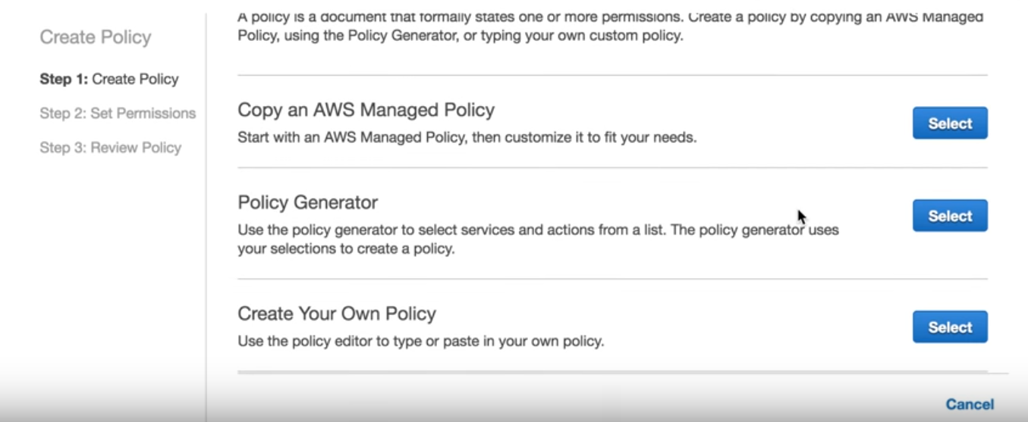

3. 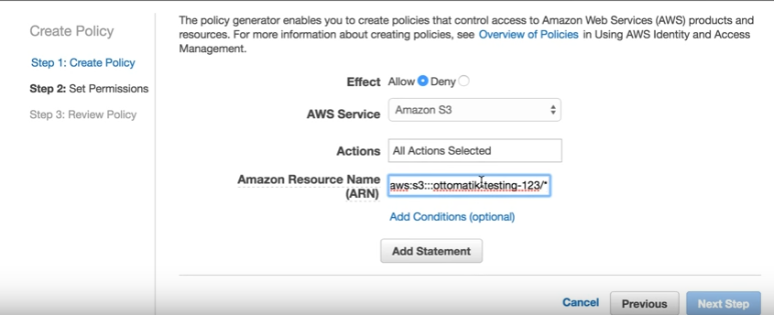

Set the permissions as below

Effect: Allow

AWS Service: Amazon s3

Actions: All

ARN: arn:aws:::s3<bucket name>

And select Add statement and click on next step

4. 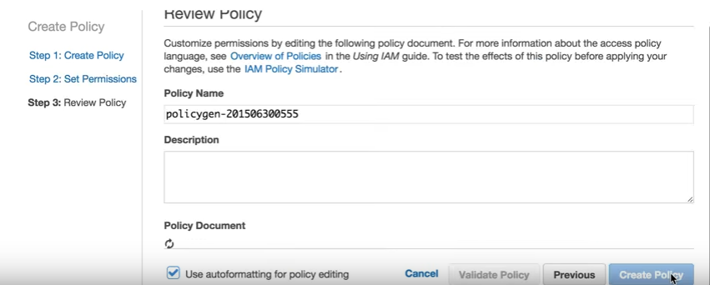

Type the policy name as required and click create policy

5. 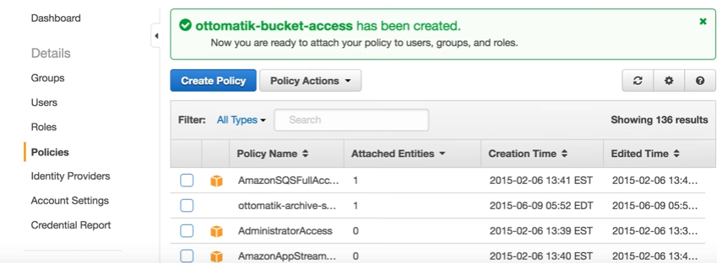

The created policy ottomatik-bucket-acess is listed and can be attached to an IAM user.With this policy the IAM user will be able to modify the bucket ottomatilk –testing-123.